Biography
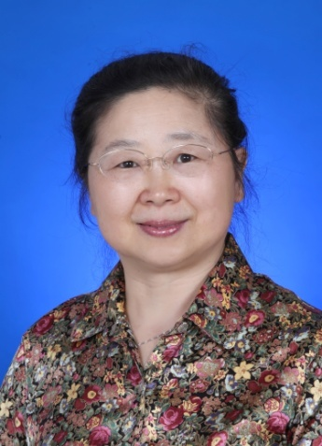
Position & Institute:

Full name: Xiumei Mo

Position: Professor on Biomaterials

Institute: Donghua University

Country: China.

Topic of the Speech:

Electrospinning 3D nanofiber scaffold for tissue engineering

Prof. Dr. Xiumei MO is a professor of Biomaterials in Donghua University. She once had two years Postdoc experience in Kyoto University, three years research fellow experience in National University of Singapore, one year visiting professor experience in Aachen University of Applied Science and Technology. In Donghua University she was granted 28 projects related with nanofiber fabrication for different tissue regeneration and hydrogel as tissue adhesive. She has published more than 300 papers. ISI Web of Science showed that she ranking No.7 in the world on electrospun nanofiber publication. She got the Science Technical Invention Awards from Shanghai Municipality in 2008，Science and Technology Progress Awards from State Department of People’s Republic of China in 2009, Nature Science Awards from Shanghai Government in 2015. She is the committee members of China Biomaterials Society as well as Biomedical Engineering Society Biomaterials Branch. She is also vice chairman of China Composite Materials Society Super-fine Fiber Branch.

(no more than 150 words):

Prof. Dr. Xiumei MO is a professor of Biomaterials in Donghua University. She once had two years Postdoc experience in Kyoto University, three years research fellow experience in National University of Singapore, one year visiting professor experience in Aachen University of Applied Science and Technology. In Donghua University she was granted 28 projects related with nanofiber fabrication for different tissue regeneration and hydrogel as tissue adhesive. She has published more than 300 papers. She got the Science Technical Invention Awards from Shanghai Municipality in 2008，Science and Technology Progress Awards from State Department of People’s Republic of China in 2009, Nature Science Awards from Shanghai Government in 2015. She is the committee members of China Biomaterials Society as well as Biomedical Engineering Society Biomaterials Branch. She is also vice chairman of China Composite Materials Society Super-fine Fiber Branch.

